run kraken-report (normally all should be done via qsub, but do this command directly on login node - its not good practise at all!! but its a little fast job)

kraken-report --db /home/projects/co_23260/data/databases/minikraken_20171013_4GB kraken.out > kraken.report

**Report below:**

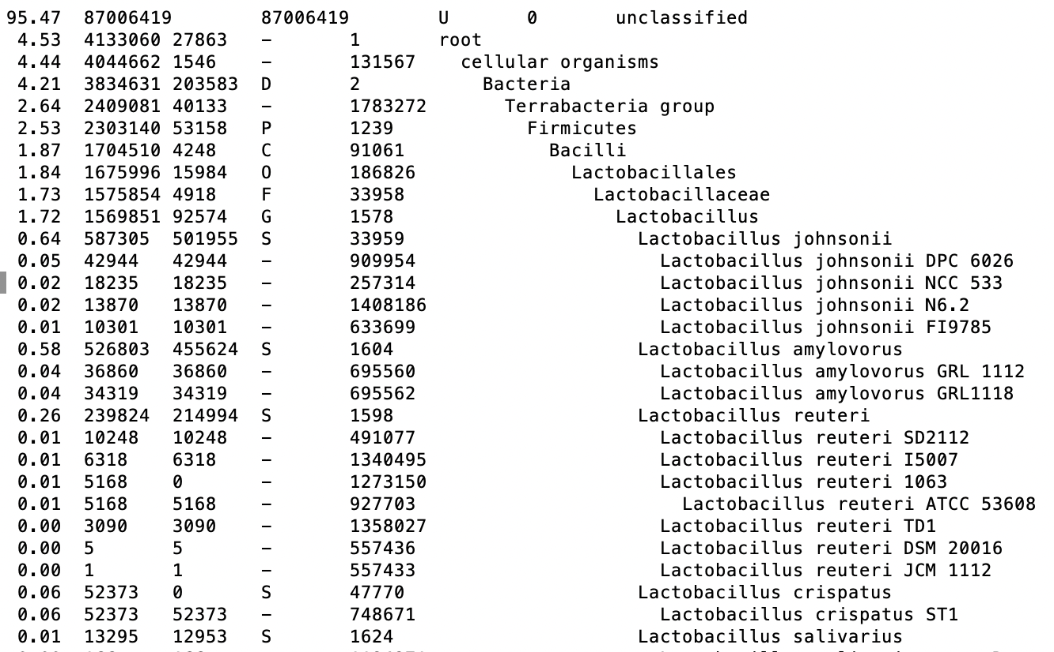

1. **Percentage of reads are classified?**

Approx. 4%

1. **What are the names top 1 most abundant species and genus?**

Species – Lactobacillus johnsonii

Genus - Lactobacillus

1. **How many reads are assigned to top 1 species and genus?**

Lactobacillus johnsonii - 33959

Lactobacillus - 1578

**Run kraken2 using kraken2.pbs.sh template from apps/ directory**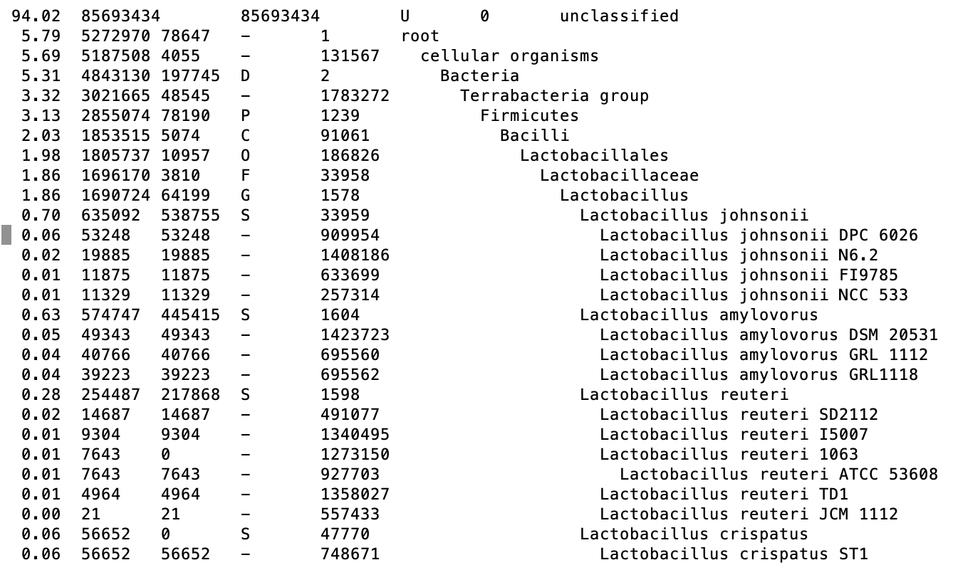

1. **Percentage of reads classified**

Approx 6%

1. **Name the top 1 most abundant species and genus**

Species – Lactobacillus johnsonii

Genus - Lactobacillus

1. **How many reads are assigned to top 1 species and genus**

Lactobacillus johnsonii - 33959

Lactobacillus - 1578

Bracken:

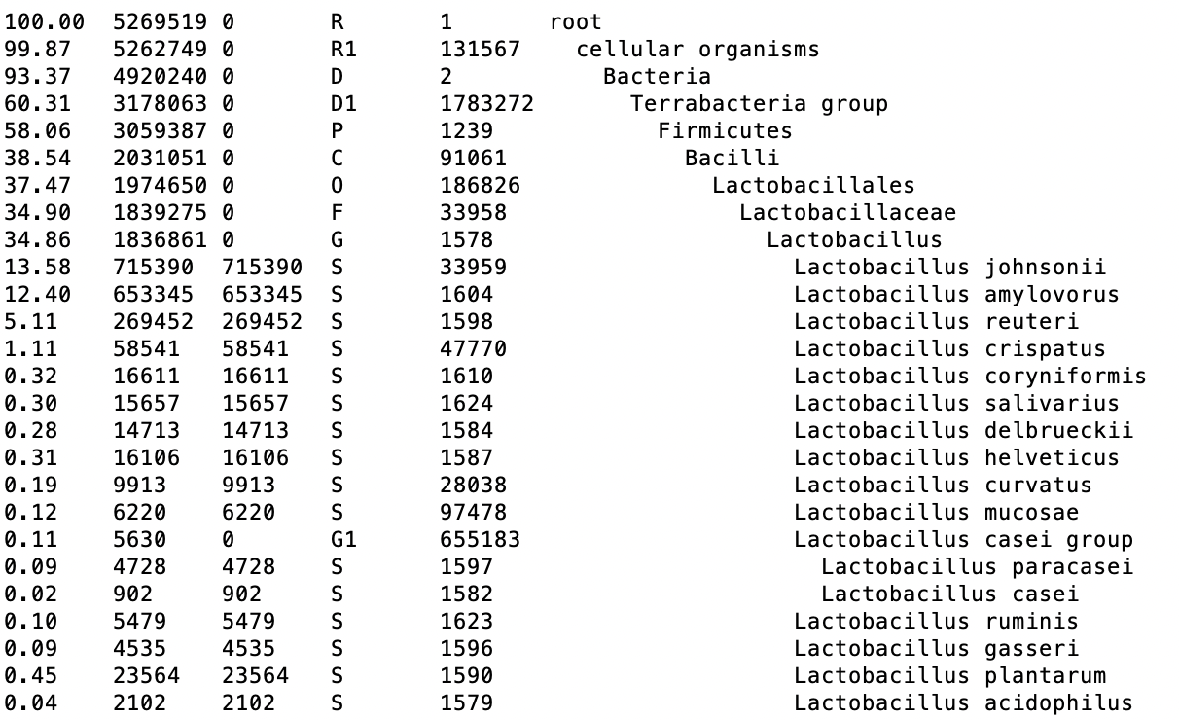

run command (takes 1 sec to run): bracken -d /home/projects/co_23260/data/databases/minikraken2_v2_8GB_201904_UPDATE -i kraken2.report -o bracken.S.out -w bracken.S.report -r 150 -l S -t 10 > bracken.S.summary

1. Name the top 1 most abundant species and genus

Species – Lactobacillus johnsonii

Genus - Lactobacillus

1. How many reads are assigned to top 1 species and genus

Lactobacillus johnsonii - 33959

Lactobacillus - 1578

1. How many species are there in your sample

From summary file:

>>> Number of species in sample: 4032